# 

# Proposal on Automating Snap Assembly

Juan Rojas

AIST Vision and Manipulation Group

Wednesday, November 2nd, 2011

Contents

Proposal on Automating Snap Assembly 1

Snap Assembly Overview 2

Background Literature 3

Considerations 7

Proposal 9

Work Flow 13

Schedule 13

Contributions 14

Bibliography 15

## Snap Assembly Overview

Snap assembly is similar to the regular assembly of parts but it differs in at least two ways. The nature of the insertion of parts by nature contains an elastic element to it. There are three different kinds of snaps parts [], which can be visualized in Figure 1:

* The cantilever snap,
* The annular snap joint, and
* The torsional snap joint.

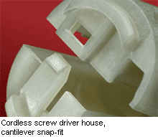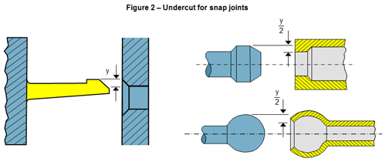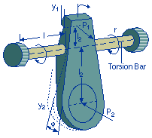

Figure 1: Examples of a Cantilever Snap, an Annular Snap, and a Torsional Snap

Each of these three parts has an install direction and an assembly motion not to mention different geometries []. All of these parts are elastic whose stress limits on the strain of the material. Most plastics deform about 50% of their stress breakpoint while most polymers bend about 60-70% of their breaking stress.

Secondly, snap assembly systems vary from simple to complex. Simple systems occur in when only one part needs to be assembled, whether cantilever, torsional, or annular. However, often times in many industrially fabricated goods, plastic parts come with more than one snap joint, with different geometries, and perhaps elastic properties.

Generally, the snap assembly problem is comprised of three to four different steps to accomplish the task: a) Localization, b) force profile characterization, c) snap implementation, and possibly, d) desnapping.

However, the snap assembly problem has only been studied in very simple cases and no work that I know of has been able to perform snap assembly in a generalized manner. That is to say, researchers have taken a single assembly system and attempted their method on that system alone. Some work has been done in the generalization of the traditional assembly-of-parts task and provides a very useful example for possible work in the snap assembly domain.

A goal in robotic automation is to implement robotic systems that can deal with uncertainties and flexibly adapt to new environments. Some are currently working on this ability to generalize and it is our goal to contribute towards that end.

## Background Literature

**Localization Methods**

Localization in snap assembly has primarily been implemented by blind searches encompassing simple linear or radial searches that scan a desired area to find a goal position. The methods usually follow a discrete path plan to find the insertion point for the assembly. Sometimes these works try to improve their search-completion-time by optimizing search parameters the step size of their motions or the speed of the motions.

Some have also adapted localization methods in the mobile robotics community to detect the position of an object when it is held. In these cases, Bayesian filtering and particle filters have been common approaches in the modeling of the system. Others have used particle filtering to fuse visual and proprioceptive data for localization.

* Search Strategies
  + In [], the authors automated the assembly of a mobile phone by implementing a force-guided set of robotic skills that included stopping, alignment, and sliding. By using fine manipulation and hybrid PD control, the authors implemented the respective assembly and also optimized its speed.
  + In [], a switch is snapped into a box. A force guided robot used a constraint-based task methodology to perform the assembly. A state-machine directed a linear search. The automata initiated with linear searches in the –z, y-, and x-directions and transitions between these when there is a ‘big contact’ in the z-direction, y-direction, and x-direction respectively. Additionally, one there has been contact in a particular direction, the next state will also encompass force control for that direction. The last three states in the FSM contain, not linear, but rotational motions about the roll, pitch, and yaw directions along with the same force control scheme dictated in the first three translational motions. The systems uses vision to estimate distances between search stages and uses this information to learn optimal motion speeds for the search.
* Probabilistic Methods
  + In [], Chhatpar and Branicky used particle filters to localize a key-lock assembly. In this experiment, visual assistance was unavailable. Their strategy involved in creating a contact map of the assembly system prior to localization. In order to handle discretization errors and multiple localization solutions due to global initial uncertainty, the authors used a particle filter implementation that was highly successful in localizing the key-lock hole.
  + In [], Platt *et. al.* used the idea of localization commonly applied in mobile robotics to track the position of the objects held in the hand. To do so, Platt used Bayesian Filtering to localize the unobserved state of the flexible material. Furthermore the posterior distribution was represented using a particular filter. Finally, the author handles the possibility of state estimation errors in the training set by modeling the likelihood as a Gaussian mixture model.
* *Main Challenges*
  + The papers described in search strategies denote search strategies that are not optimal. There has been work done in using intelligent search techniques to guide parts into assembly based on higher-level interpretations of force and moment signals. These two works only handle one snap joint. It was assumed that the robot knew how to approximate the region of interest, and then performed hybrid linear-constant-force searches to find the snap. In these cases there was no effort in trying to approach the part directly, nor were there examples in which two or more snap joints were localized and upon which the assembly was performed.
  + Both of the surveyed probabilistic methods use the same approach to localize: they use a training stage to form a contact map type and then run particle filters on online trials to find an optimal location. The first work only finds a centroid for a type of peg-in-hole location, the second one localized snap features based on a single haptic map but it did not generalize well to features of different sizes or geometries.
  + There are good opportunities to investigate how to deal with more than one snap joint. This is important as often snap joints do not occur in isolation. How do we visualize them? How do we localize them? How do we approach them?

**Force Profile Characterization and Snap Implementation**

* Process Monitoring
  + In [], Sikka and McCarragher suggested a new approach to discretize the assembly task into discrete states by the use of discriminant functions and clustering technique. The discriminant functions were learned from real sensory data which makes them adaptable to new tasks.
  + In [], Hovland and McCarragher, used frequency domain force measurements to recognize discrete events in an assembly task. In this case, Hovland and McCarragher used Hidden Markov Models to represent contact state transitions and not the state itself. In this work, the authors estimated the mean and covariance of the energy of the frequency components of the FT measurements.
* Unsupervised Learning Methods
* In [], Asada learned to map associated forces with corrective motions along a nominal path using neural networks to execute non-linear compliance control in assembly tasks. Asada Associated wrench data with velocity data by encoding a small set of discrete contact states for a peg-in-a-hole assembly task and performed action learning through Q-learning.
  + In [], Newman *et. al.* guided assembly searches (localization) by using a mapping between sensed moments ${(M}_{x},M_{y})$ and corrective motions $(△x,△y)$. Newman used a Backpropagation Neural net with k-means to find the inverse relationship between moments $(M_{x},M_{y})$, and relative displacements ($△x,△y$). He added a quality measure to the contact-state map to distinguish between regions of low-value, medium-value, and high value. Higher-value areas were weighted more heavily in the displacement computation. He also learned from regions of low value and single erratic FT measurements that considering the FT sensory data history of records in the computation is necessary.
* Probabilistic Models
  + In [], Stolt *et. al.* modeled the force profile as a multi-variate Gaussian distribution. In doing so, they devised a test by which they could predict the execution of the snap if the random variable data was within the bounds of a hyper-ellipsoid.
* *Main Challenges*
  + The words from process monitoring seem fundamental in being able to categorize different stages of an assembly task. Their work assumes a small set of contact states that where limited to analyzing the force in the x- and y-directions and the torque in the z-direction $\{F_{x}, F_{y}, T_{z}\}$ and also considered a limited set of contact states that may not always occur. This presents a good opportunity to find new discriminant functions that generalize better for different sizes and features in the six-dimensional space of force wrenches.
  + The neural network training in these methods assumes simplistic contact states with corresponding motion responses that don’t generalize well to different features and tasks. It seems difficult to apply the neural network method under this framework if we want to generalize more complex tasks and for different sizes and features.
  + The direct mapping of moment values to corrective motions is problematic because there are many regions in the task space that have ambiguous data and similar values. For this reason Newman had to generate quality measure maps.
  + There are good opportunities to understand how transitions in continuous space can be understood in conjunction with overall force/torque magnitudes to classify the status of an assembly task. A hypothesis is that there are symmetries *in transition signal*s that exist across an assembly task regardless of feature geometry and size.
* Generalization
  + In [], Thomas *et. al.* try to solve the whole chain process of the peg-in-whole assembly method by fusing visual sensory data and FT information via particle filters. Their method creates FT maps from CAD-data models prior to the assembly. Their approach was successful for experiments with variations of the peg-in-hole tasks.
  + In [], Marvel *et. al.* sought to provide adaptable solutions to the insertion assemblies by integrating generic assembly strategies with tunable parameters. The parameters are self-tuned empirically using a Genetic-Algorithm learning process that minimized assembly time subject-to contact-force limits. The authors demonstrated their approach by performing automotive assemblies using two industrial ABB robots and commercial force-control software.
* *Main Challenges*
  + The CAD approach presented by Thomas *et. al.* seems appropriate for industrial robots but not applicable to machines that work in unstructured and varying environments. To this end, being able to learn based on goal objectives and experience is crucial.
  + The genetic algorithm is a very useful idea on how to render robots more flexible by adjusting parameters with generic search strategies to perform assembly tasks with variants in them. Such an approach could be valuable in snap assembly optimization. The challenge lies in finding effective reward functions while minimizing the search space to find solutions faster.

**Desnapping**

* Thus far no work has been identified in the desnapping process.

## Considerations

The considerations presented in this list follow the goal to automate the snap assembly process. This entails the localization of parts, the implementation of the snap, with its verification process, along with desnapping.

However, these steps can only be considered after a careful examination of underlying conditions that define the snap assembly problem.

Snap Type, Install Direction, and Assembly Motion

As we saw in the introduction of this proposal, there are three different kinds of snap parts: the cantilever snap, the annular snap, and the torsional snap. Each of these snaps has an install direction and an associated assembly motion as stand-alone snap joints. The *install direction* is the direction in which the motion should be constrained and the *assembly motion* is the type of motion necessary to complete. They are summarized as follows:

1. Cantilever Snap
   * Install Direction: 1D translational motion.
   * Assembly Motion: Linear Push.
2. Annular Snap:
   * Install Direction: 1D translation motion + 3D rotational motion.
   * Assembly Motion: Push.
3. Torsional Snap:
   * Install Direction: 1D rotational motion.
   * Assembly Motion: Rotational push.

Direction Constraints in Multiple Joint Configurations

For situations in which there are more than one snap joint configurations it is important to determine if there is a way to constraint the motion explicitly or implicitly in order to simplify the snap assembly. That is to say, consider the assembly part shown in Figure 2.

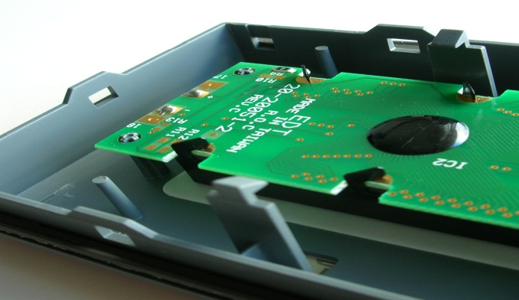

top

Figure 2 – Multiple Cantilever Joints in Electronics Mold

In this scenario, the snap assembly could begin with a vertically downwards motion that seeks to make simultaneous contact on both cantilever snaps at the same time. However, due to uncertainty in position, this would make it a very fragile motion given that, unless contact is made simultaneously on both snap joints, the probability of missing the insertion could be high.

For this kind of assembly, humans often make use of constrained motions to simplify assembly tasks with multiple joints. In practice, it would be common to lock the corresponding mating part into the opening labeled as “top” in Figure 2 and then continue with a rotational motion that simplifies the approach of the mating part unto the snap joints.

Snapping Verification

No work has done in verifying whether a snap occurred successfully. All papers focus on getting to the snap location and then report successful snaps at that point.

Snap joints are designed to facilitate the insertion and locking of parts, but without a verification step at this stage there is no guarantee that the snap has properly locked. Furthermore, if the snap has not been verified to have completed successfully there is no opportunity to activate any recovery error mode.

Desnapping

So far there is no work reported in the literature on robots performing desnapping. This may be so due to little interest in the subject. Perhaps in industrial environments the need for robots to desnap is low but in unstructured environments where robots interact with humans connecting and disconnecting objects is a desirable skill.

## Proposal

The proposal for research and implementation presents ideas testbed, focus areas, algorithm, and the work flow which outlines the execution of various developmental stages of research work ranging from simple to more complex.

**Testbed**

The selection of a testbed requires that Hiro is able to interact with the medium. The testbed must also contain snap joints with prime elastic properties that can yield useful force profiles. It is also desirable that the testbed is composed of parts that are easily accessible, modular, and extensible in order to use the same testbed in more complex scenarios. And, ideally, the testbed will be useful and attractive in terms of the service it can render to the public.

Lego

Several initial suggestions are presented. The first one is the Lego product is suggested as the testbed of choice. Lego products come in the right size for Hiro to handle the parts. Lego parts use light snap joints to connect parts together and they occur in all kinds of shapes and configurations. The variety of ways in which Lego’s can be connected allow for us to test simple and complex configurations. They are also easily recognizable by color and geometry simplifying the visualization and localization tasks. They also provide added value in that having a robot like Hiro build Lego shapes, even possible building a Lego robot, can be a very attractive application for our work providing a framework for edutainment.

This testbed would allow for further work in domains of insertions, snaps, connection and building strategies which are of wide interest across multiple domains. However, there is a big concern with this testbed; it remains unclear if the force profiles yielded by the Lego set will be useful. Preliminary testing will be needed to see the kinds of profiles generated by the Lego set.

Potential Lego sets are suggested: [here](http://shop.lego.com/en-US/Banana-Balance-3853?s=4611734), [here](http://shop.lego.com/en-US/Meteor-Strike-3850?s=4567569), and [here](http://shop.lego.com/en-US/LEGO-Champion-3861?s=4611742).

Other suggestions include: i)using cell phone plastic molding with good snap joints that Hiro can use to assemble the phone; ii) a [jacket with grommets](http://images.efollett.com/spirit/v4/695/5101-VANDY.jpg) whereby Hiro snaps the grommets together to put the jacket on; and iii) use power strips that have torsional snap to connect electronics. Hiro could insert/disconnect electronics on a power strip.

**Focus Areas**

There are four focus areas I identified to automate snap assembly. Some areas may have short term and the long term goals.

1. Control Strategy
   1. Simple search strategies constructed empirically and encoded by a state machine while using simple controllers (i.e. hybrid position force control, compliant control, control basis). The simple controller can be used to test other elements of the assembly process like the force profile characterization and optimization. For examples, see [] and [].
      1. Assumes the goal reference position is available.
   2. Development of more efficient and appropriate techniques for snap assembly. Some ideas are:
      1. Ideas such as ‘gentle shakes’, to enable difficult to do insertions;
      2. Constraint-based motions depending on geometry of parts,
      3. Energy-based motions to achieve simplest path for complex structures are of interest.
      4. Assumes the goal reference position is available and that the test-bed has been identified for simple and more complex configurations.
   3. These proposals would also apply to desnapping procedures.
2. Process Monitoring and Verification Scheme?
   1. I propose a force profile classification scheme based on classifying stages of the assembly with linear gradients, then providing such gradients with a qualitative description, and then compounding qualitative descriptions in a hierarchical nature to represent higher level abstractions of stages in the snap assembly problem. This is explained next with more detail:

Consider an artificial force data signal in the z-direction implemented during a snap assembly task.

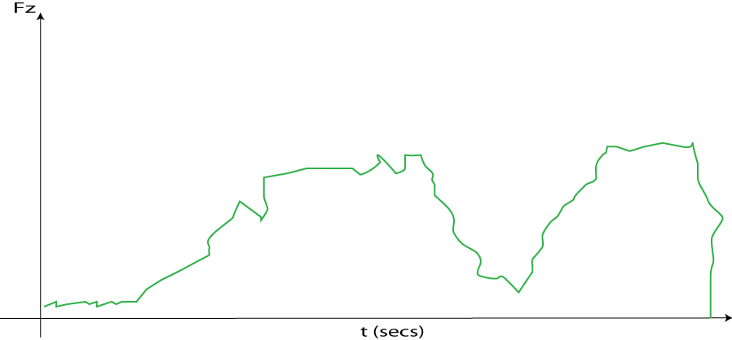

The task is primarily described by the way things change within stages of the snap assembly. For example, for all snap assembly tasks there will be: a guarded approach over the air, a contact point, a surface slide, an insertion, another kind of contact at the end of the insertion, and a desnap.

These stages can be deciphered by looking at how things change within the force profile data. We can guess that different stages of the insertion can be divided as follows:

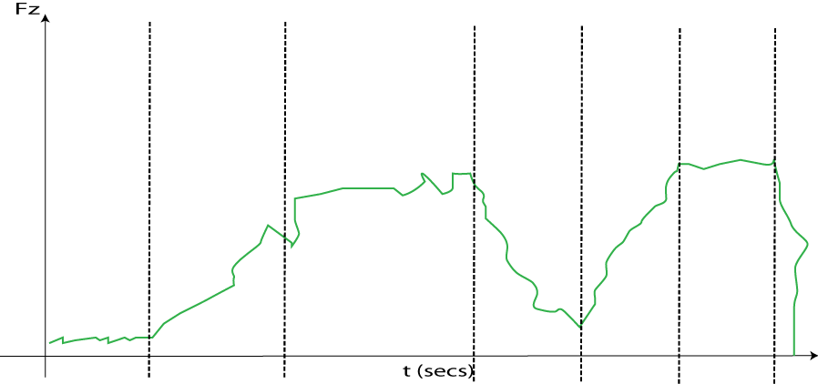

Each section can be filtered to obtain a linear segment whose gradient can be qualitatively described with a tag describing its *approximate* behavior:

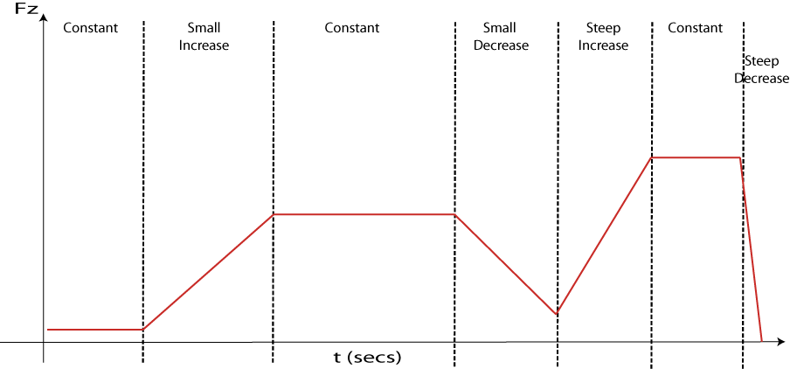

*Approximate* is important and hard to define at the same time. There is noise in the signal at each state that is meaningless. This noise ought to be identified and removed while keeping the relative force profile response for a given stage[1].

At this stage, compound associations can take place (through on-line supervisory learning methods or unsupervised learning methods) to characterize higher level behavior. These compound associations build on top of each other to build hierarchical terms that inherently consider sensor readings. See the following associations for example:

* Initial Contact = constant episode + small increase
* Search = Initial Contact + Constant
* Insertion = Search + Small Decrease
* Insertion Contact = Insertion + Steep Increase
* Snap = Insertion Contact + Constant
* Desnap = Snap + Steep Decrease  
  1. Using these classification procedure online-learning algorithms can be used with experience to probabilistically predict whether or not new assembly attempts are following an appropriate sequence of events or whether the trial attempt is predictably failing. If a failure motion is being detected, then a recovery motion can be enacted by seeking to reverse the motion and try again with a small variation.

1. Optimization
   1. By identifying parameters for the search strategy (i.e. step-size, speed, applied force, etc.) optimizations techniques can be adopted to generate optimal assemblies.
      1. Some good examples exist in the area of evolutionary algorithms, more specifically genetic algorithms [].
2. Visualization/Localization
   1. Visualization: An approach may consist of having the robot first look at the held part, study the geometry of the object, and then determine the number of assembly joints along with their geometry. After that it would look at the corresponding mating part and find the corresponding mating joints. It would then try to generate a strategy on how to approach the mating part.
   2. Localization: The last stage is designing a probabilistic approach to the localization of single/multiple snap joints that is able to generalize. A potential approach could be the use of a particle filters.

Work Flow

## Schedule

## 

## Contributions

Concretely we are looking to make contributions in the fields of:

* Process Monitoring and Verification Strategies specific to the Snap Assembly Process.
* Snap Assembly Control Strategies.
* Localization of various snap joint configurations.
* Optimization Methods for the snap assembly.

## Bibliography

[1] J. M. Hoffman, “Fastening and joining fundamentals of annular snap-fit joints,” *Machine Design*, vol. 77, no. 1, pp. 82–88, 2005.

[2] K. S. Chin, M. M. Ratnam, and R. Mandava, “Force-guided robot in automated assembly of mobile phone,” *Journal of Assembly and Automation*, vol. 23, no. 1, pp. 75–86, 2003.

[3] A. Stolt, M. Linderoth, A. Robertsson, and R. Johansson, “Force controlled assembly of emergency stop button,” in *IEEE Int’l Conf. on Robotics and Automation*, 2011.

[4] S. Chhatpar and M. Branicky, “Localization for robotic assemblies using probing and particle filtering,” in *Int’l Conf.on Advanced Intelligent Mechatronics*, 2005.

[5] R. Platt, F. Permenter, and J. Pfeiffer, “Using bayesian filtering to localize flexible materials during manipulation,” *IEEE Transaction on Robotics*, vol. 27, no. 3, pp. 586–598, 2011.

[6] P. Sikka and B. J. McCarragher, “Monitoring contact using clustering and discriminant functions,” in *IEEE Int’l Conf. on Robotics and Automation*, 1996.

[7] G. Hovland and B. Carragher, “Frequency-domain force measurements for discrete event contact regions,” in *IEEE Int’l Conf. on Robotics and Automation*, 1996.

[8] H. Asada, “Teaching and learning of compliance using neural nets: Representation and generation of non-linear compliance,” in *IEEE Int’l Conf. on Robotics and Automation*, 1990.

[9] W. Newman, Y. Zhao, and Y. Pao, “Interpretation of force and moment signals for compliant peg-in-hole assembly,” in *IEEE Int’l Conf. on Robotics and Automation*, 1, Ed., 2001, pp. 571–576.

[10] U. Thomas, S. Molkenstruck, R. Iser, and F. M. Wahl, “Multi sensor fusion in robot assembly using particle filters,” in *IEEE Int’l Conf. on Robotics and Automation*, 2007.

[11] J. A. Marvel, W. S. Newman, D. P. Gravel, G. Zhang, J. Wang, and T. Fuhlbrigge, “Automated learning for parameter optimization of robotic assembly tasks utilizing genetic algorithms,” in *IEEE Int’l Conf. on Robotics and Biomimetics*, 2008.

1. Identifying what’s relevant and what’s depends on defining what is big and small for the given stage of the task.